**Applications**

Dobby Grey fabrics are manufactured using extreme precision. It is also modified by patterns and weaving to suit various purposes.

They have a wide range of application across industries that manufacture diapers to industries that manufacture home decor. It also is widely used to manufacture decent handbags and basic polo shirts.

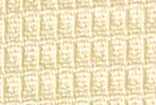

**Honey Comb**

40sPC x 20sPC 124 x 56 - 63''

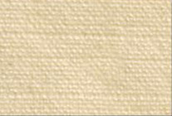

**Cotton Rib Stop**

2/40sC x 16K 88 x 60 - 63''

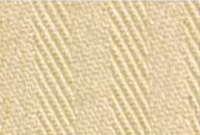

**Herring Bone**

16sK x 12sLy 108 x 60- 61''

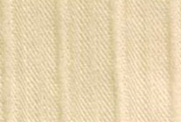

**Lycra Continious Dobby**

40sC x 40sLy 140 x 64- 61''

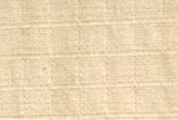

**Lycra Rib Stop**

20sK x 16sLy 96 x 46 - 61''

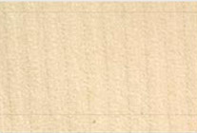

**Reverse Twill**

40sC x 25s lea 92 x 52 - 63''

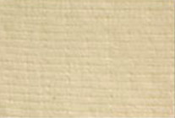

**Rib Stop**

40sC x 40sC + 16 Ly 134 x 70 - 63''



**Dobby With Lenolycra & Jari**

40sC x 40sCLy 124 x 56- 61''

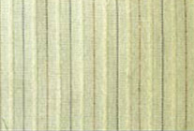

**Block Jari With Lycra**

40sC x 40sCLy 124 x 56- 61''

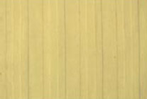

**Dobby Satin Stripes With Lycra Jari**

40sC x 40sCLy 124 x 56- 61''

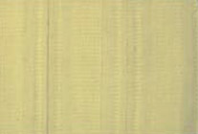

**Honey Comb + Satin Stripe With Jari Lycra**

40sC x 40sCLy 124 x 56- 61''

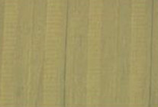

**Honey Comb With Jari Lycra**

40sPC x 20sPC 124 x 56 - 63''

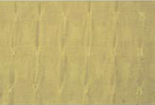

**Window Dobby With Lycra**

40sC x 40sCLy 124 x 60- 61''

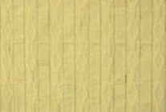

**With Honey Comb Design**

40sC x 40sCLy 124 x 56- 61''

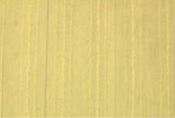

**Dobby With Jari With Leho**

40sC x 40sCLy 124 x 56- 61''



**Dobby Design With Jari With Leho**

40sC x 40sCLy 124 x 56- 61''

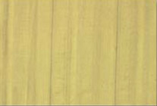

**Dobby Multi Design With Jari With Lycra**

40sC x 40sCLy 124 x 56- 61''